**NAME: SYEDA ALAINA**

**ID NO: BIT-23F-040**

**COURSE: ARTIFICIAL INTELLIGENCE**

**SECTION: A**

**SEMESTER: 3RD**

**LAB: 1**

**LAB TASK 1:**

1. Make 2 programs of each data type.

**NUMERIC DATA TYPES:**

**CODE:**

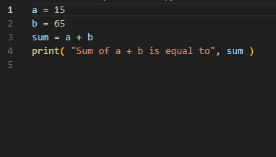

**OUTPUT:**

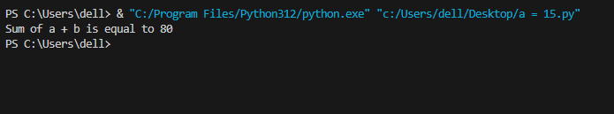

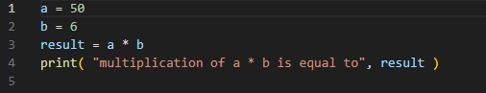**CODE:**

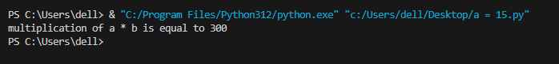**OUPPUT:**

**FLOAT DATA TYPE:**

**CODE:**

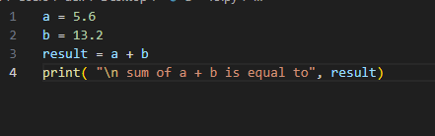

**OUTPUT:**

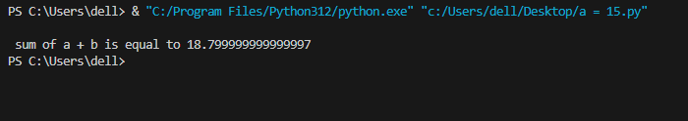

**CODE:**

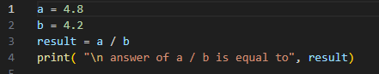

**OUTPUT:**

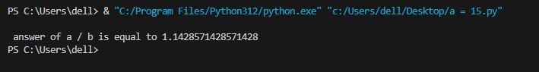

**COMPLEX DATA TYPE:**

**CODE:**

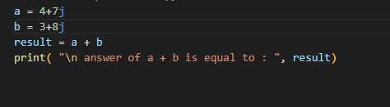

**OUTPUT:**

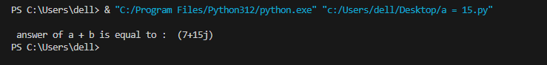

**CODE:**

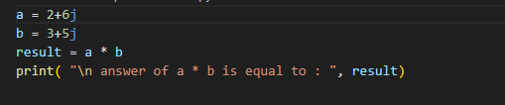

**OUTPUT:**

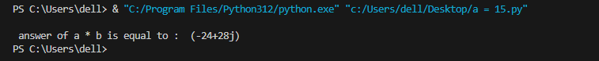

**BOOLEAN DATA TYPE:**

**CODE:**

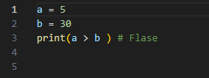

**OUTPUT:**

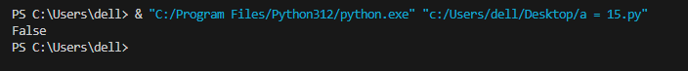

**CODE:**

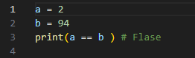

**OUTPUT:**

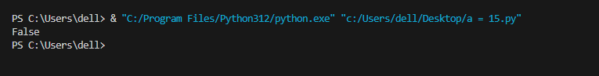

**SEQUENCE DATA TYPES:**

**CODE:**

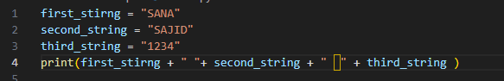

**OUTPUT:**

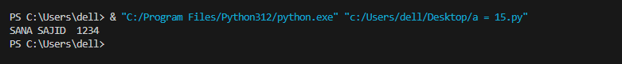

**CODE:**

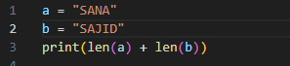

**OUTPUT:**

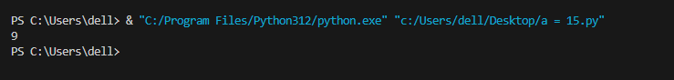

**LAB TASK 2:**

1. Make 10 shapes using string

**SQUARE SHAPE**

**CODE:**

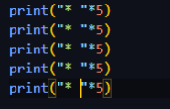

**OUTPUT:**

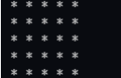

**RIGHT TRIANGLE SHAPE**

**CODE:**

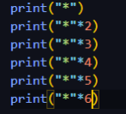

**OUTPUT:**

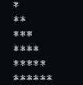

**TRIANGLE SHAPE**

**CODE:**

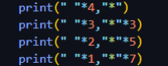

**OUTPUT:**

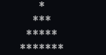

**DIAMOND SHAPE:**

**CODE:**

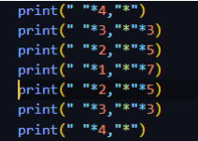

**OUTPUT:**

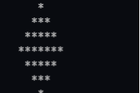

**HOLLOW SQUARE SHAPE:**

**CODE:**

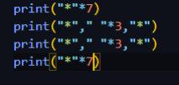

**OUTPUT:**

